

Mathematics Department |  | 
Course: A2MAA
Topic Title: Test 3 Calculator Assumed
Student Name:_____________________________________ | Date: ____________
Special Instructions: Formula Sheet allowed and calculators | Time Allowed: 30 minutes
Show all working clearly | Marks: / 28

Question 1. (4 marks)

Find the value of $x$ in each of the following. (diagrams are not to scale)

- (2 marks)
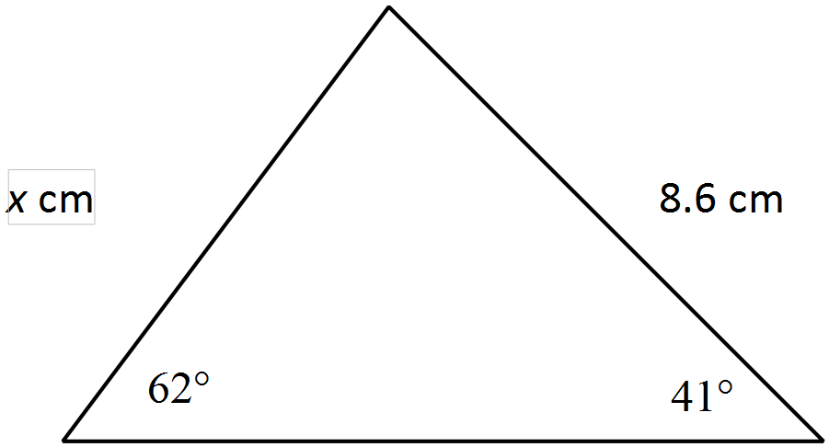

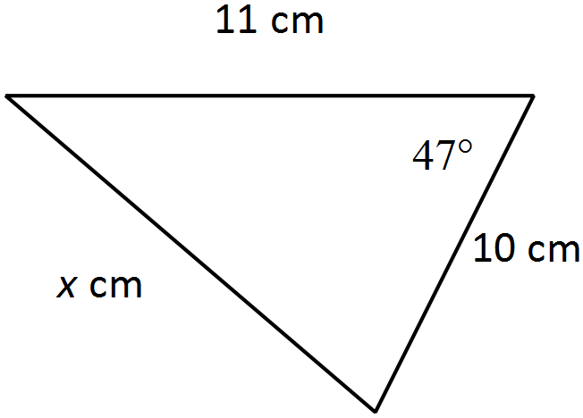
b) (2 marks)

Question 2. (3 marks)
A ladder leans against a wall inclined at an angle 27° to the horizontal. If the ladder reaches 7.5m up the wall, what is the length of the ladder?

Question 3. (6 marks)

From the top of the cliff, ship A is observed at an angle of depression of 15°, 35m from the base of the cliff. At the same time ship B is observed 12m from ship A as shown in the diagram below.

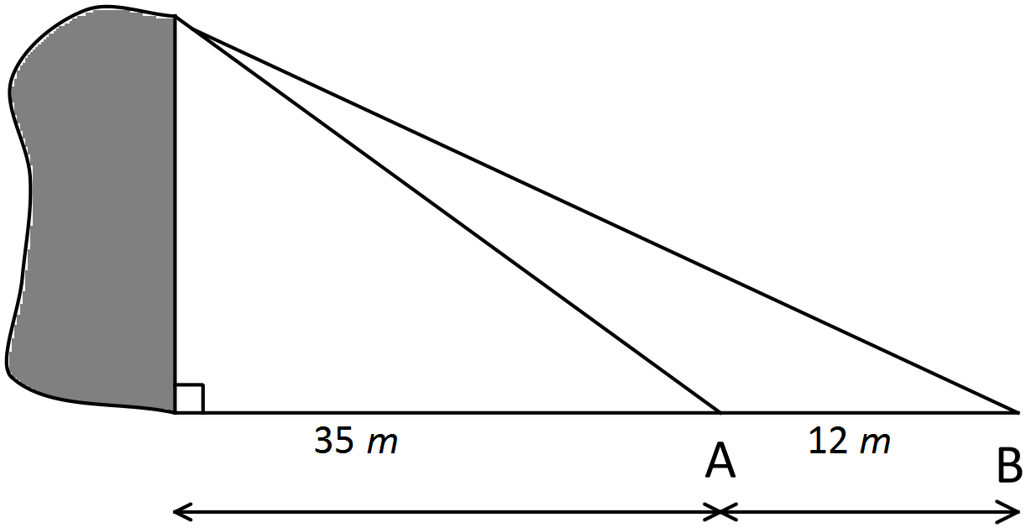

Determine:
- The height of the cliff (4 marks)

- The angle of elevation from ship B to the top of the cliff (2 marks)

Question 4. (3 marks)

A triangle has an area of 767.69 cm². The lengths of two of the sides of the triangle are 43.1cm and 38.7cm. Find the size of the angle between these two sides.

Question 5. (8 marks)
Ship A leaves port P travelling 120km west. Ship B leaves port on a bearing of 215° travelling 120km.

Find:
- the distance between the two ships (2 marks)

- the bearing of ship A from ship B (4 marks)

- the bearing of ship B from ship A (2 marks)

Question 6. (4 marks)

Consider the triangle below.
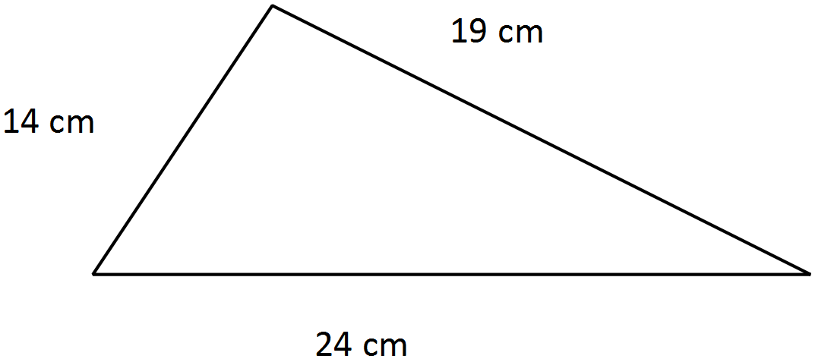

Use Heron’s formula to calculate the area of this triangle.

